Test evidences fde-2

Test 1 — All Groups PRIMARY (Happy Path)
All three groups have return_pct. Expect: HTTP 200, status=VALID, degraded=false, no warnings.
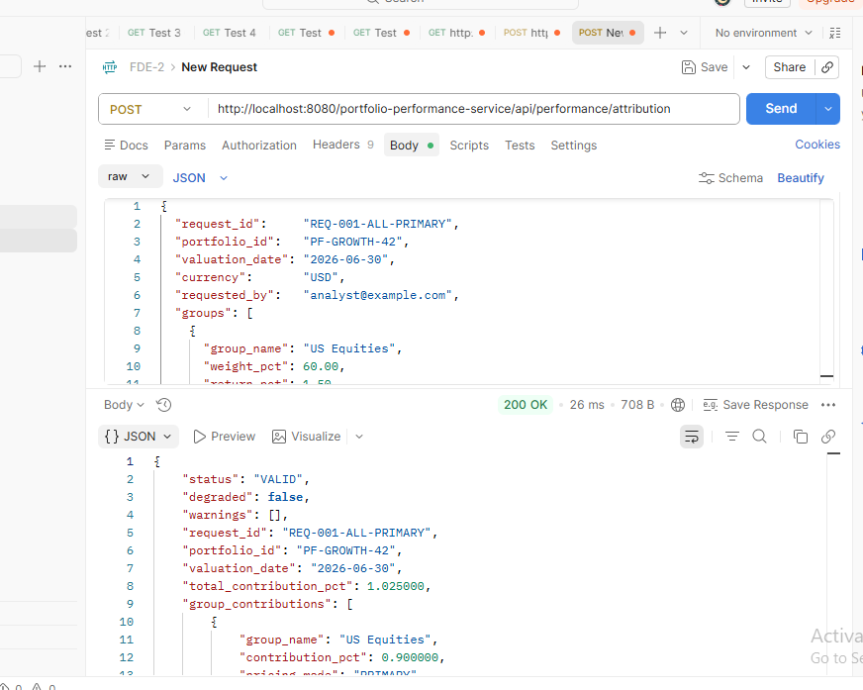

Test 2 — One Group FALLBACK_USED
Fixed Income has no return_pct but has fallback_return_pct. Expect: HTTP 200, status=VALID, degraded=false, 1 warning.
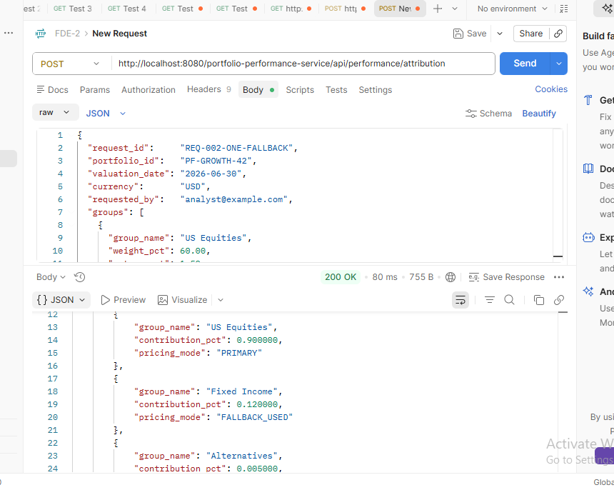

Test 3 — All Groups FALLBACK_USED (Edge Case)
Every group has return_pct=null but a valid fallback_return_pct. Expect: HTTP 200, status=VALID (not DEGRADED), degraded=false, 3 warnings.
